**Multi proccessing in Python**

<https://github.com/Deepanshu-TTN/bootcamp-git/blob/master/week-5/Regular%20Expression%20and%20Text%20Proccessing/npiPOST.py>

Q)Update npiPosts assignment to work with multithreading

Update: added a concurrent threads approach for better execution time

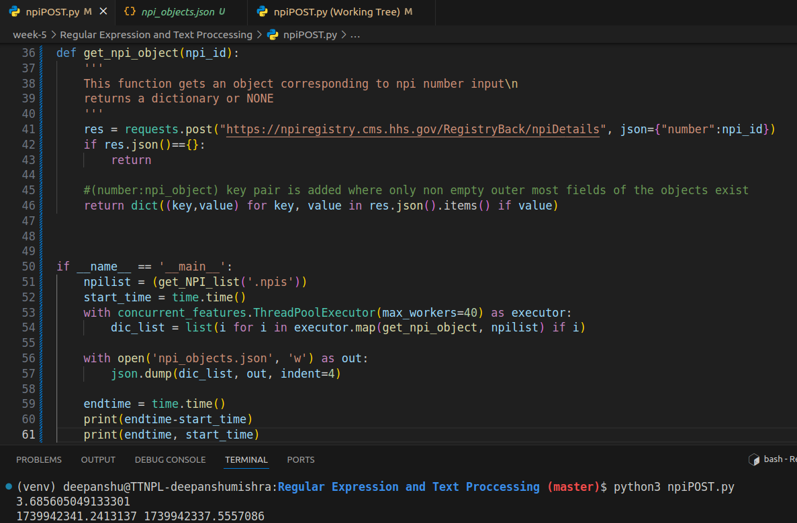

Updated the previous function to dump a list as well for consistent output json

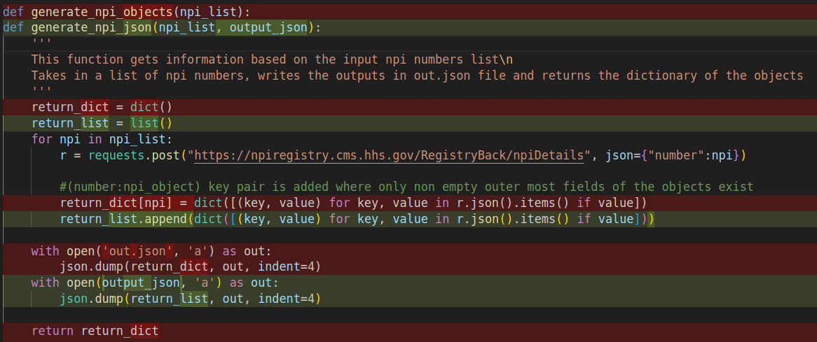

Also Updated the formosa scraper script:

The main function without threading:

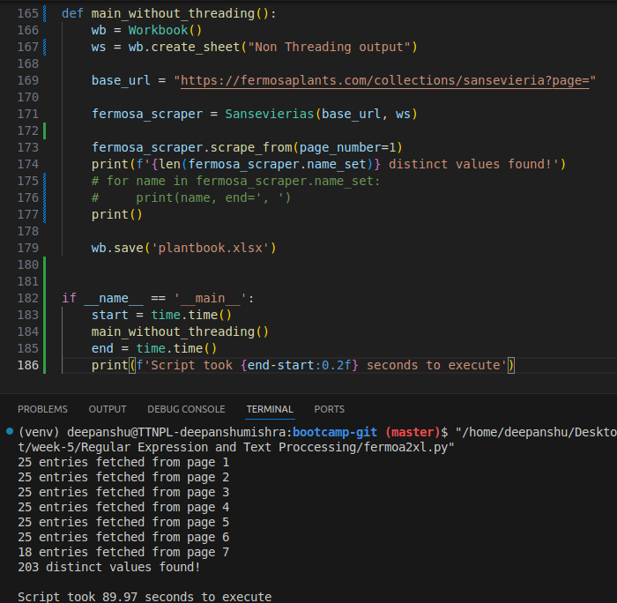

This approach took almost 90 seconds to execute

Created a middle function to call the two modules from a single method call: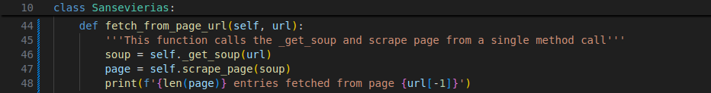

After calling this method for all the pages from separate threads, the execution time drops to 13.05 seconds

